QC Portal Automation

Proposal Report

Thomas Wilkinson
Giatec Scientific Inc.
Date: May 25th, 2025

Table of Contents
Problem Statement: 2
Current Implementation 2
Future Implementation 2
DB Input Validation Function 20
1: General Operations 3
2: Seal Tests 12

Problem Statement: Entering results for General Operations and Seal Test tests into QC Portal is unnecessarily repetitive, leading to wasted time and inducing errors.

Current Implementation
General Operations: To update general operations tests the QC team is currently fetching sensor voltage values from Grafana then manually inputting them into the database one sensor at a time. This process can sometimes be repeated for hundreds of sensors per session.
Seal Test: To update seal test tests the QC team manually inputs the initial/final/delta weights of the sensors along with their resets, samples, and missing samples into the database one sensor at a time. This is usually done for 10 sensors at a time.

Future Implementation
General Operations: To update General Operations tests the user will simply need to insert the mac IDs of the sensors they wish to update and choose which CM they want to fetch the MFT data from. Then, the program will automatically extract the voltage values and error statuses of each sensor (related to the specified CM) from the MFT database and present them in an organized table. The user will then be able to analyse the data in the table and choose whether they want to commit it into the Inspection database or not.
Seal Test: To update Seal Test tests the user will simply need to insert the mac IDs of the sensors they wish to update. This will create a template csv file containing the inserted macs. Then, the user will download this file, fill in the empty columns, and reupload it. They will then be presented with a table in which they can verify the data before committing it for good.
Note: These implementations do not create new inspection records, rather, they just update pre-existing ones.

1: General Operations: Proposed Workflow Breakdown
Client Constraints:
- Client wants to be able to input test data for multiple sensors at a time.
- Client wants to be able to choose which CM (by name) to collect data from.
- Client wants to make sure collected data is correct before inserting in DB.
- Client wants to know what mac addresses aren’t valid, if any.
- Client wants to know what mac addresses aren’t found in DB, if any.
- Client wants to know what mac addresses aren’t found in DB in relation to chosen CM, if any.
- Client wants to know if data has successfully been inserted into DB.
Assumptions:
- Said sensors must have already gone through MFT for functional testing.
- This development part will not create any new records, only update existing ones.
- This development part will copy pre-tested records and do the necessary updates as described in the document.
Proposed solution:
The following flowchart shows the steps that will be taken by both the user and the program while going through the proposed implementation:
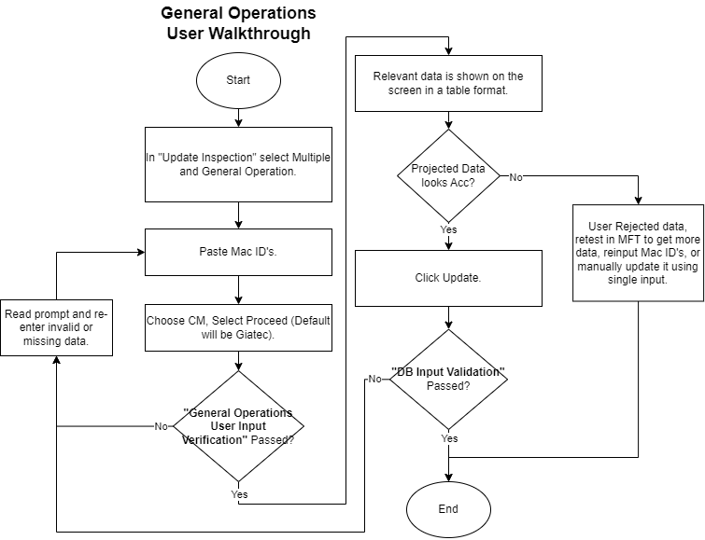
Figure 1: User walkthrough for data entry of General Operations test.
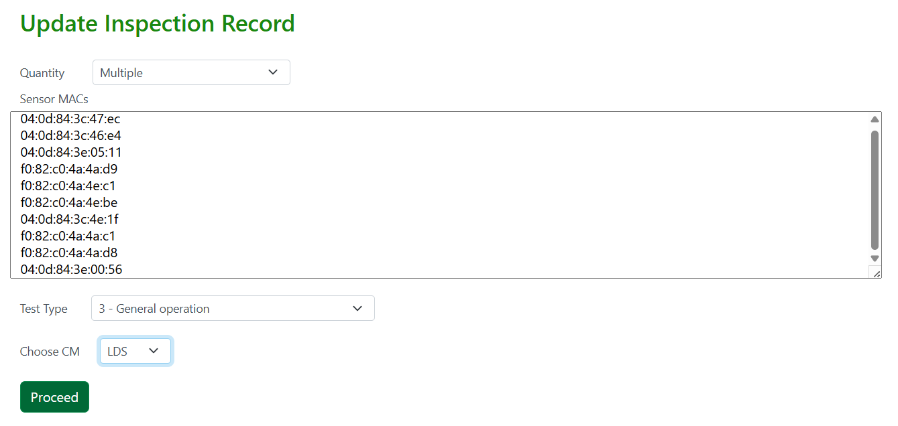
Figure 2: Inserting Mac Addresses into the "Sensor MAC's" textbox.
Once the user has inserted the mac addresses and chosen their preferred CM as seen in Figure 2, they can click on the “Proceed” button. If the inserted data is found to be valid, a table like the one in Figure 3 will show up, for more information on how the data is validated check out the “General Operations User Input Verification” function under Functions).
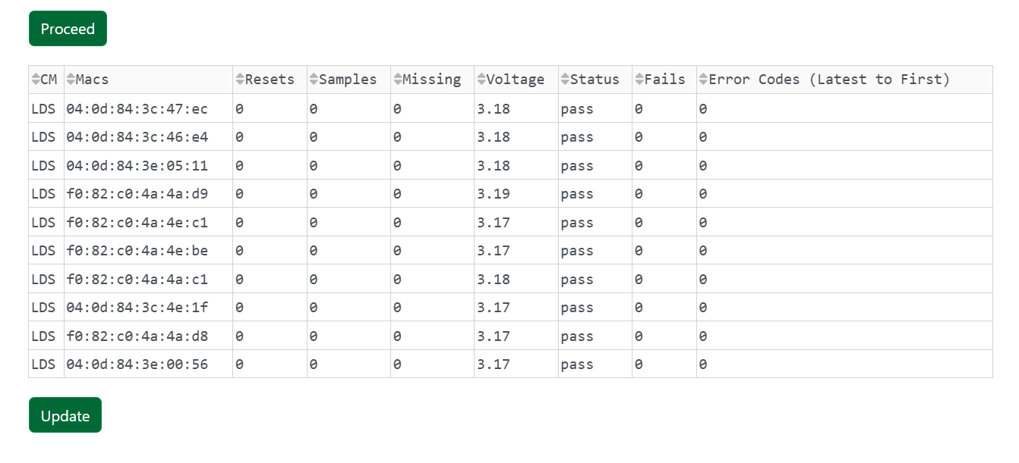
Figure 3: General Operations proposed layout.
In Figure 3, the first column of the table shows which CM the sensor was tested at, this data will not be inserted into the Inspection DB. The second column shows the inserted mac addresses, each representing a sensor. This will be used to relate the sensors to their pre-existing inspection record in the Inspection DB. The third, fourth, and fifth columns contain data that will be inserted into the details column of the inspection.record table as seen in Figure 4. These include the number of resets, samples, and missing samples of each sensor, which should all be 0 (therefore they are set to 0 by default). If, for some rare case, the user wishes to update a sensor where, either resets, samples, or missing samples, are not 0, they can do so using the single sensor insert approach. The battery voltages, error statuses, and error codes are shown in the last three columns and are extracted from the MFT database. The voltage values and the latest error code will be inserted into the details column of the inspection.record table while the status values will be inserted into the passed column of the same table as seen in Figure 4.
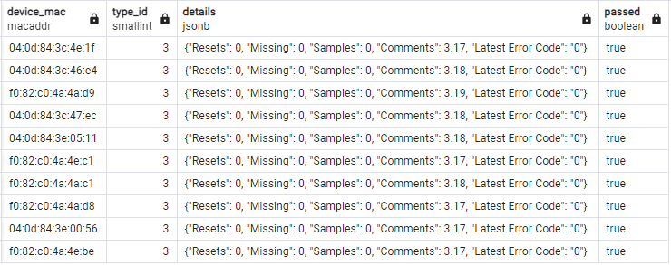
Figure 4: Relevant columns in inspection.record table on “pgAdmin”.
Once the user has looked over the data presented in Figure 3, given that they find no issues, they can then press “Submit”. The program will then run through the “DB Input Validation” function (which is also explained further in the Functions section) and, if the data is found to be valid, the user will receive a prompt indicating that the data has been successfully inserted into the database.
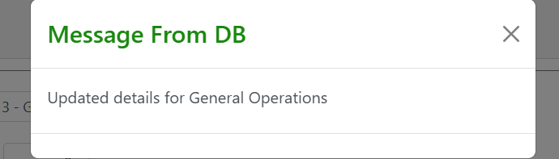
Figure 5: “Inspection Records successfully updated” prompt.
Necessary Schemas and Tables:
For the General Operations test we need to extract data from one part of the database and then insert it into another. Firstly, when the user inserts the mac addresses and choses a specific CM, the voltages and error statuses relating to those mac addresses, and CM are extracted from the MFT database and shown in the table from Figure 3. As seen in Figure 6 below, this step requires the use of the mft.dut, mft.sessions and common.cm_users tables.
Add legend
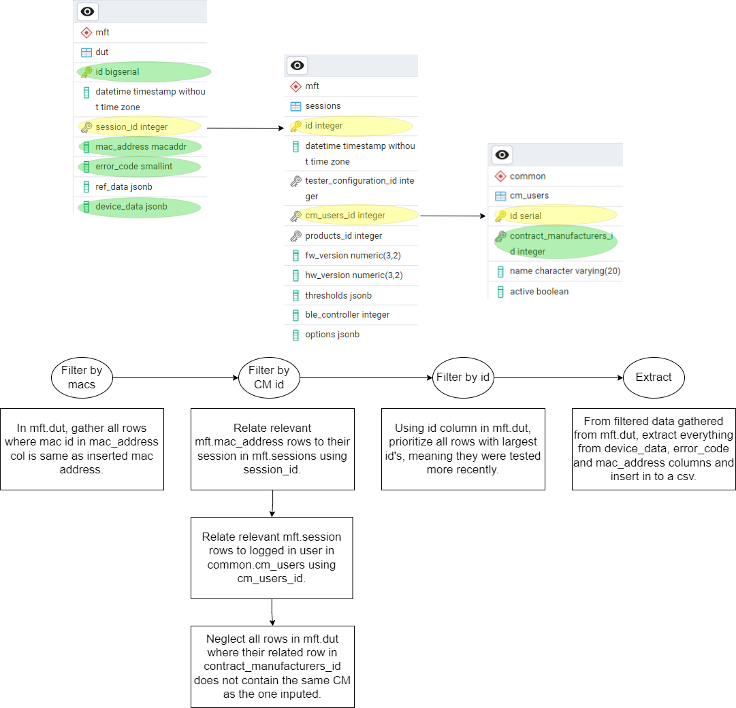
Figure 6: Important tables for extracting sensor voltages and statuses.
Figure 7: General Operations data extraction from MFT Database.
Secondly, when the user decides to submit the data into the database, it will be inserted into the Inspection database using the inspection.reocord and inspection.device tables.
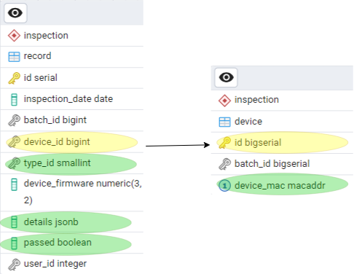
Figure 8: Important tables for inspection record updates.
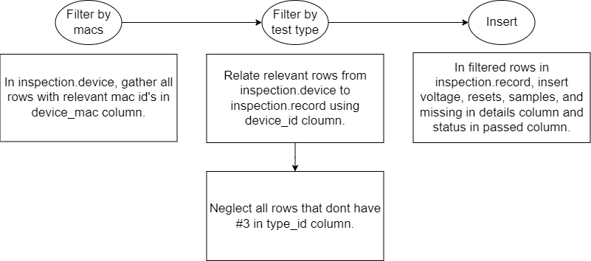
Figure 9: General Operations data insertion into the Inspection database.

2: Seal Tests: Proposed Workflow Breakdown
Client Constraints:
- Client wants to be able to input seal tests results using a file.
- Client wants to be notified if contents of file has not been inserted correctly.
- Client doesn’t want to be able to create seal test, only update.
- Client wants delta to be calculated in backend.
Assumptions:
- Said sensors must have already gone through Seal Test and must already have been weighed.
- There can not be duplicate mac ids in inspection.device table.
- This development part will not create any new records, only update existing ones.
- This development part will copy pre-tested records and do the necessary updates as described in the document.
Proposed solution:
The following flowchart shows the steps that will be taken by both the user and the program while going through the proposed implementation:
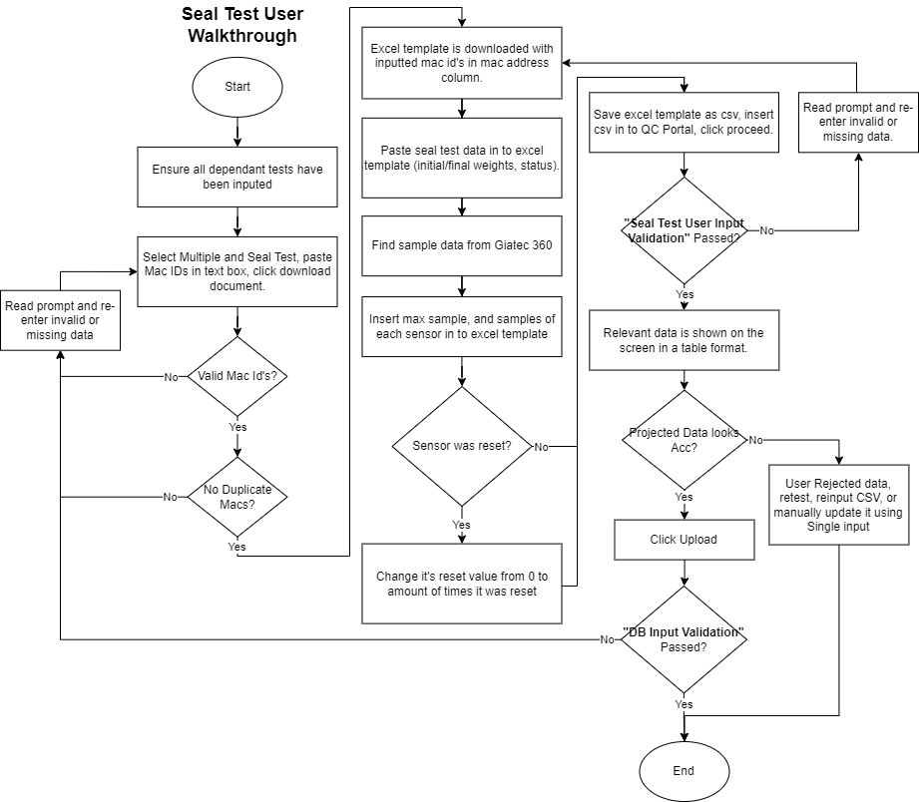
Figure 10: User walkthrough for seal test data entry.

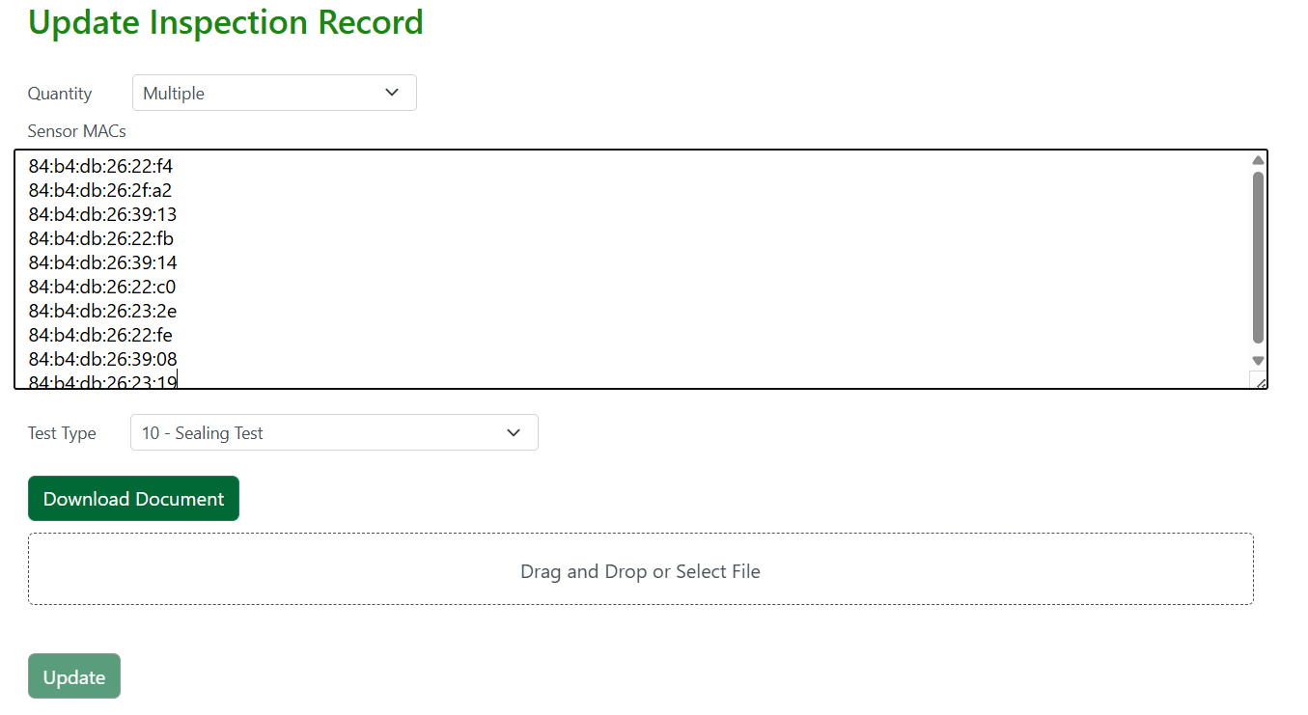
Figure 11: Proposed layout for Seal Test data entry.
Once the user has inserted the mac addresses, they can click on the “Download Document” button. If the inserted data is found to be valid, an excel document with a template (like Figure 10) will be downloaded. Once the user fills out the empty template columns they can reupload the file into the portal. If there are no issues with the inserted data a table like the one in Figure 11 will show up, for more information on how the data is validated check out the “Seal Test User Input Verification” function under Functions).

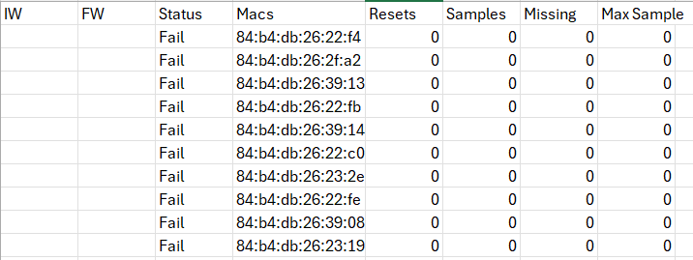
Figure 12: Seal Test downloadable template.
In Figure 11, the first column shows the inserted mac addresses, each representing a sensor. This will be used to relate the sensors to their pre-existing inspection record in the Inspection DB. The third, fourth, and fifth columns contain data that will be inserted into the details column of the inspection.record table as seen in Figure 12. These include the number of resets, samples, and missing samples of each sensor, which should all be 0 (therefore they are set to 0 by default). If, for some rare case, the user wishes to update a sensor where, either resets, samples, or missing samples, are not 0, they can do so using the single sensor insert approach. The battery voltages, error statuses, and error codes are shown in the last three columns and are extracted from the MFT database. The voltage values and the latest error code will be inserted into the details column of the inspection.record table while the status values will be inserted into the passed column of the same table as seen in Figure 4.
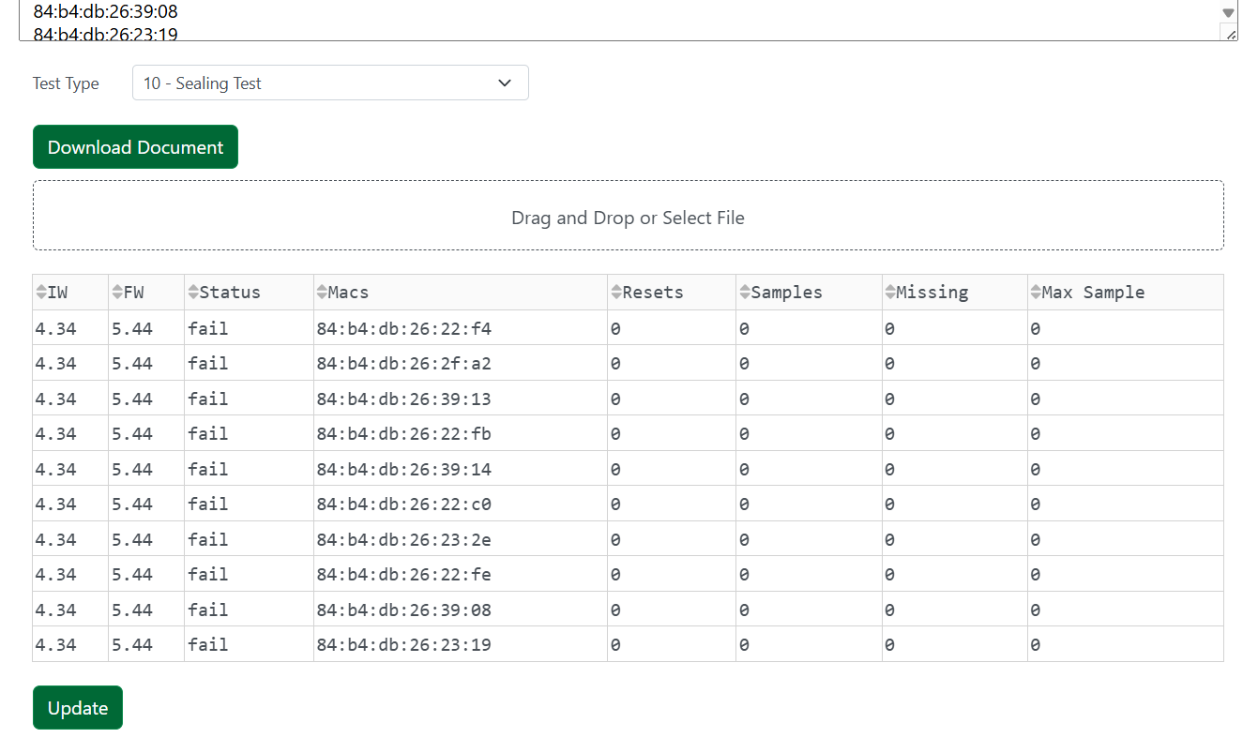

Necessary Schemas and Tables:
Read uploaded file and insert the sensor initial/final/delta weights, resets, samples, missing samples, and statuses into the inspection.record table.

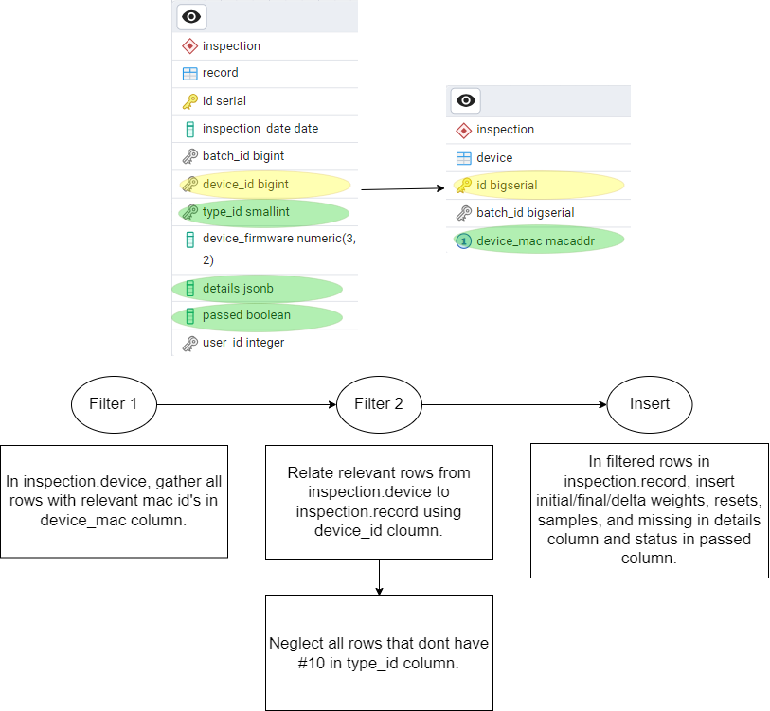
Figure 11: Seal Test data insertion.

Functions:
General Operations User Input Verification:
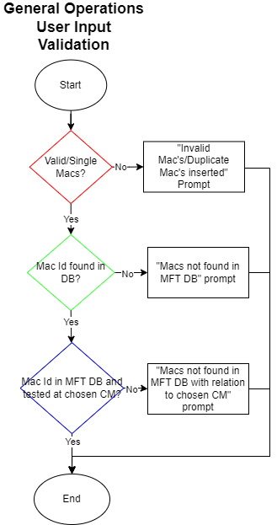
Figure 12: General Operations User Input Validation Flow Chart.
Step 1: Validate Mac Id’s
Inserted mac id’s can be with or without semicolons, however, if the latter is the case, semicolons will be added before moving forward with the next validation step. This step is comprised of one main block of code, along with two separate functions. The first function “reformat_mac” is called to insert semicolons in a mac. The second function “mac_validate” compares the mac in question with the default mac Id template and returns True if it matches the template and false if it doesn’t match the template or if the length of the mac isn’t equal to the length of a mac with or without semicolons.
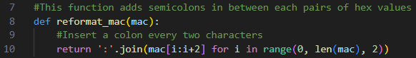
Figure 13: Reformat_mac function.
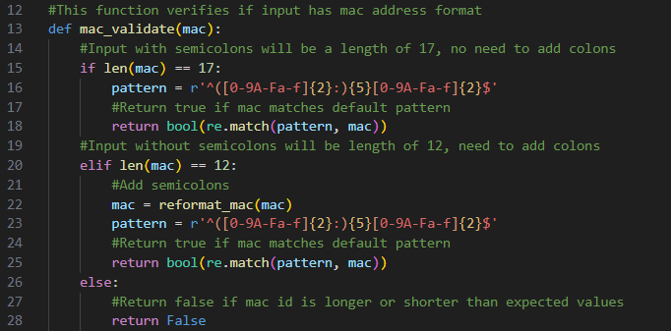
Figure 14: Mac_validate function.
The main block cycles through the inserted macs and checks if they are valid using the mac_validate function. If they are valid, it first checks the length of the mac, adding semi colons if the length is 12, then if checks if the macs are already in the good_macs list, if they aren’t, they are added to it. If the mac is not valid it will ad the mac to the bad_macs list.
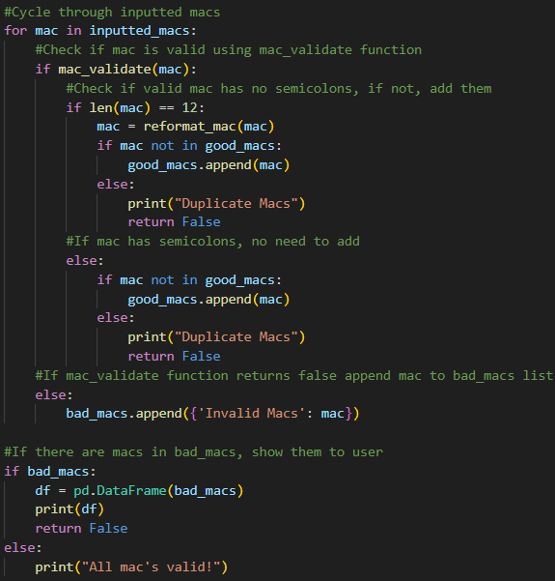
Figure 15: Main program block for mac address validation.
If a duplicate mac is found or if there are any macs in the bad macs list, the program will stop and show a prompt (Figures 16 and 17). Additionally, for the case of invalid macs, there will be a table containing the values of the bad macs as seen in Figure 18.
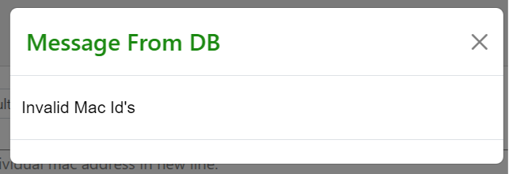
Figure 16: “Invalid mac id’s” Prompt.
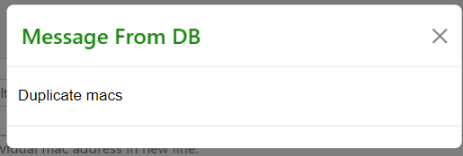
Figure 17: "Duplicate macs" prompt.
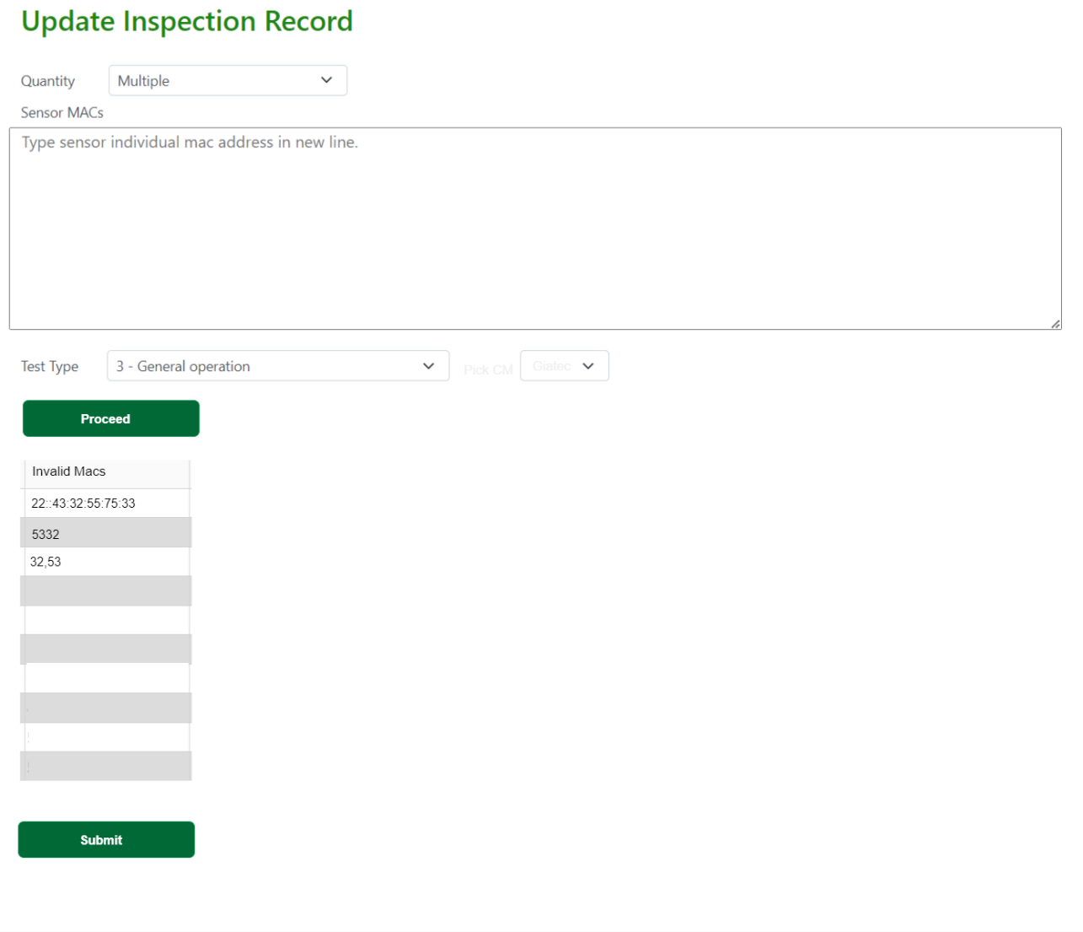
Figure 18: Invalid Macs Table.
Step 2: Check if mac Id’s are in the MFT Shema of the DB
Once Macs have past validation step, we check if they are contained in the MFT database. This is done by querying all macs that have the same value as the ones contained in the good_macs list. We then take the queried macs and compare them to the macs in the good_macs list. If there are any macs contained in good_macs that are missing from the queried data, they are printed out for the user to see (Figure 21), and a prompt is shown (Figure 20). The code for this step can be found below.
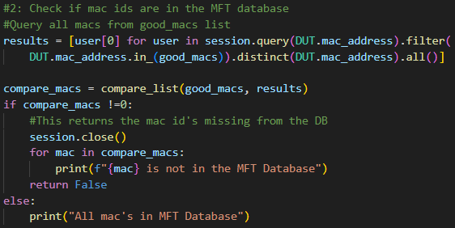
Figure 19: Main program block for checking if macs are in DB.
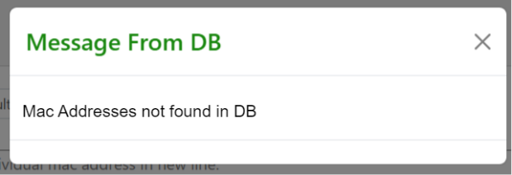
Figure 20: “Mac ids not found in DB” prompt.
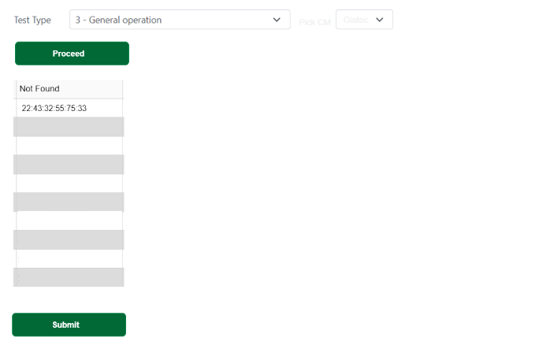
Figure 21: Mac addresses not found in MFT DB table.
Step 3: Check if mac addresses are in DB with relation to inserted CM.
Step 3 starts off by querying all mac addresses in good_macs related to the inserted CM. Then, similarly to the previous step, the queried data is compared to the good_macs list. If any macs in good_macs are missing from the queried list, they are shown to the user in a table format (Figure 24) and a prompt will be shown (Figure 23).
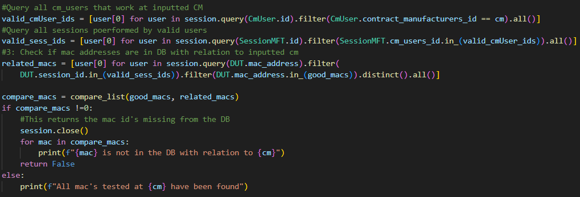
Figure 22: Query for all mac ids in good_macs related to inserted CM.
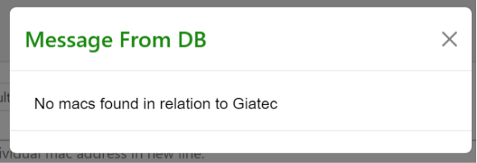
Figure 23: “No macs found in relation to Giatec” prompt.
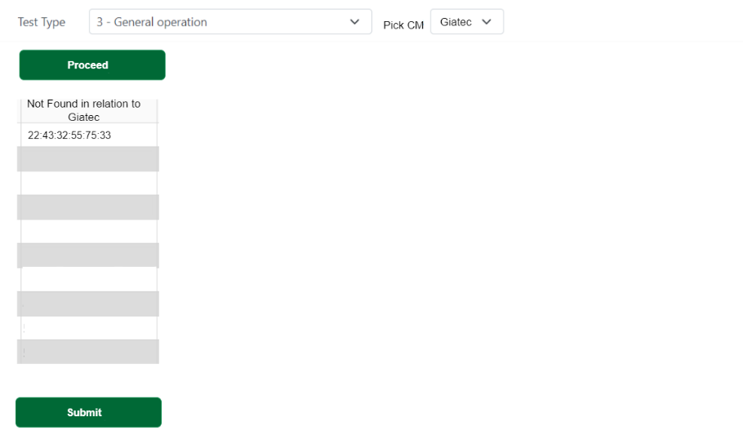
Figure 24: Mac addresses not found in MFT DB with relation to input CM.

Seal Test User Input Validation
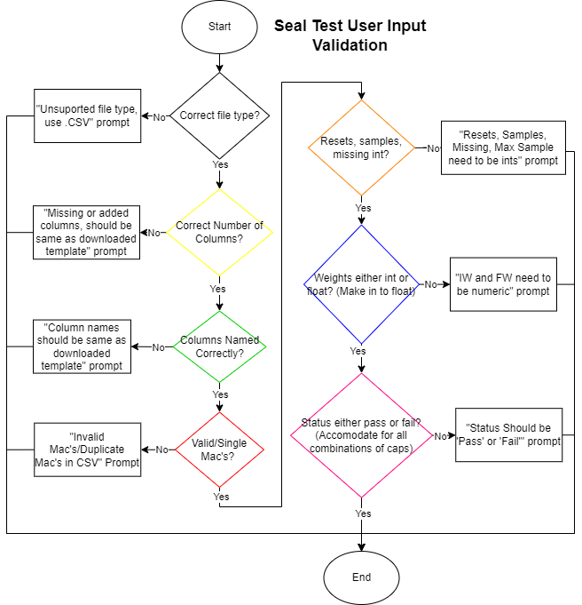
Step 1: Check if inserted file is a CSV.
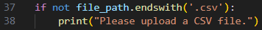
Figure 25: Program which verifies if file is a csv.
If the user has inserted an invalid file, the program will end, and the following prompt will be shown:
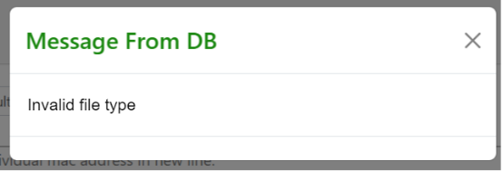
Figure 26: "Invalid file type" prompt.
Step 2: Check if input file follows the correct template
Comparing the names of the columns and their numbers to the template to make sure the inserted CSV has same amount of collumns and same names as the template. If not, the user will see a prompt like in Figure 34 and need to reupload a revised version of the file.
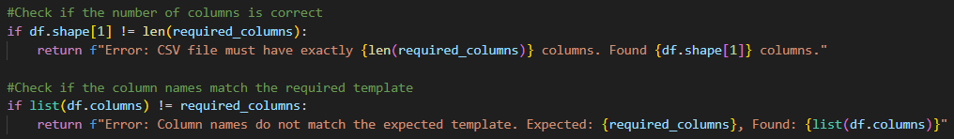
Figure 27: Code to check if the correct template was used.
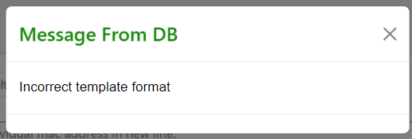
Figure 28: "Incorrect template format" prompt.
Step 3: Validate Mac Id’s/Check for duplicate macs
Using same mac id validation and duplicate check method as in general operations. If there are any duplicate macs, the program will stop and return Figure 37 as a prompt. If the entered macs are invalid, the program will stop and return a prompt along with a list of all invalid macs as shown in Figures 36 and 38.
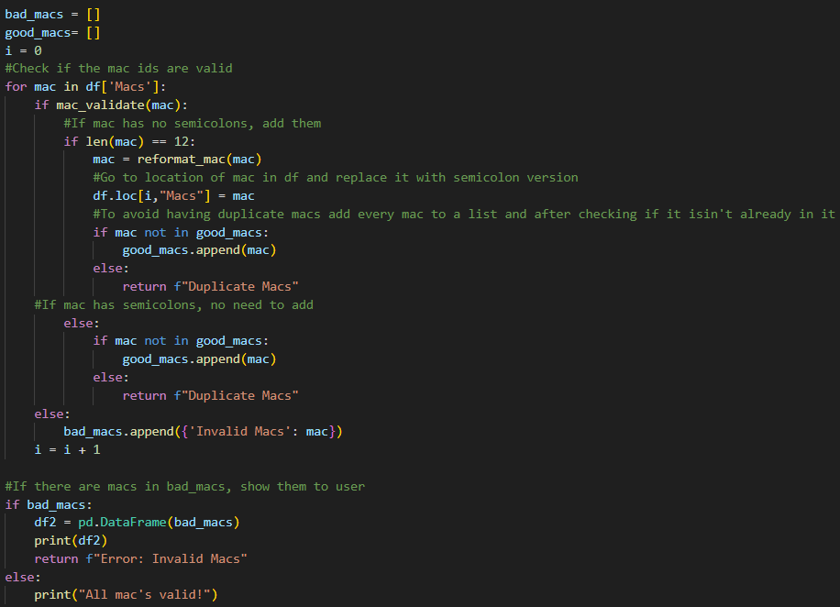
Figure 29: Program used to check if mac Id's are valid.
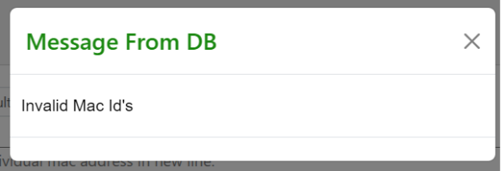
Figure 30: "Invalid mac" prompt.
Figure 31: "Duplicate mac" prompt.
Figure 32: Returned list of invalid macs.
Step 4: Make sure resets, samples, missing and max samples are ints
If any columns contain values that aren’t ints, the program will stop and return a prompt along with all columns found to have non int values.
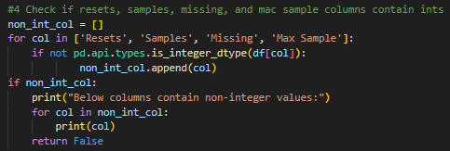
Figure 33: Program checking if resets, samples, missing, and mac samples columns contain int’s.

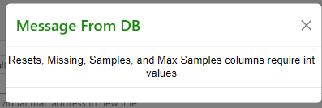
Figure 34: "Non int value" prompt.
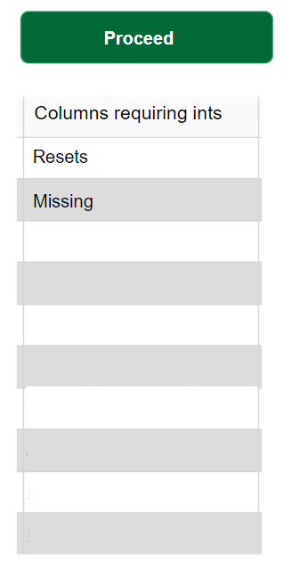
Figure 35: Table with list of all columns which have values that need to be switched to int’s.
Step 5: Make sure Initial and final wieghts are in floats or ints
If either ‘IW’ or “FW” columns contain values that aren’t ints or floats, the program will end and a prompt will be returned along with a table containing a list of all columns containing misinputted values. The values that are in ints will be converted to floats.
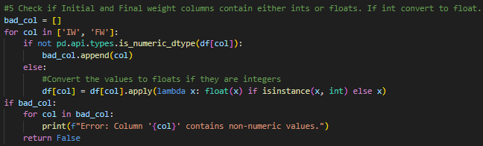
Figure 36: Program which checks if initial and final weight columns contain either floats or ints.
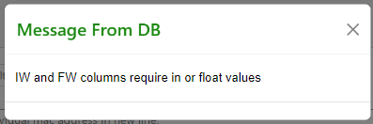
Figure 37: "Non int of float values" prompt.
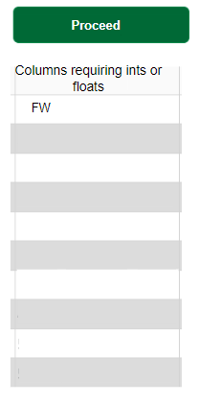
Figure 38: Table containing list of columns with incorrect input.
Step 6: Make sure values in status column are in either pass or fail regardless of cases.
This final step lowers the casing of all letters in every word in the ‘Status’ column, then check if they are the same as the two words (‘pass’ and ‘fail’) in the valid_status_values list. If any words that differ, the program will end, and a prompt will come up.
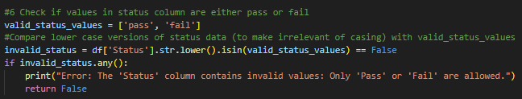
Figure 39: Program which checks if pass and fail words were inserted correctly.
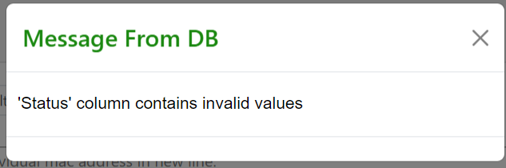
Figure 40: "Invalid values" prompt.

DB Input Validation:
DB Input Validation is a function that will be called whenever a user wants to insert some data into the inspection database. The function does three main checks:
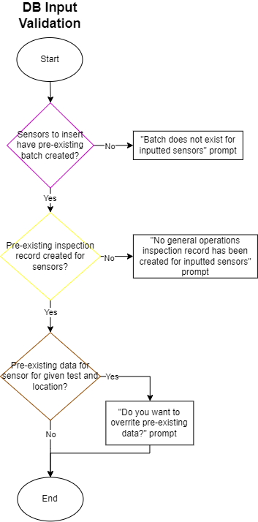
Figure 41: DB Input Validation Walkthrough.
Step 1: Check if macs are in inspection DB. 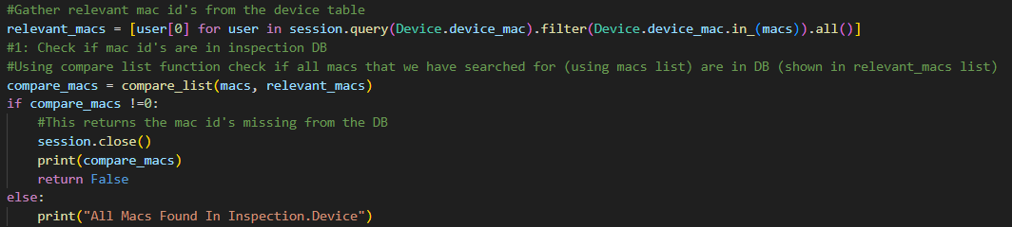
Figure 42: Code used to check if sensors in entered list are present in the inspection database.
If some macs from the input list are found to be missing in the inspection database, this means that no batch has been created for them yet, the following prompt will then occur:
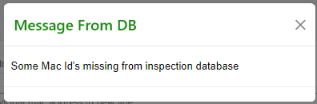
Figure 43: "Some Mac Id’s missing from inspection database” prompt.
The user will also be able to see a table containing a list of the macs that aren’t found in the DB as seen in Figure 4.
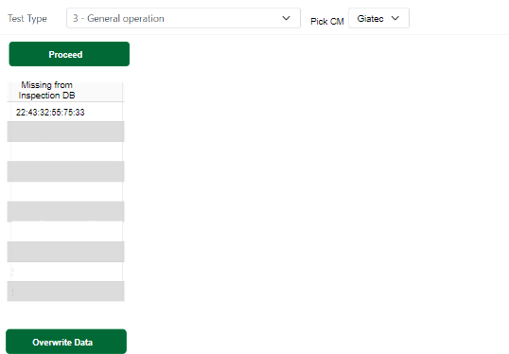
Figure 44: List of macs missing from DB.
Step 2: Check if macs are in inspection.record table.
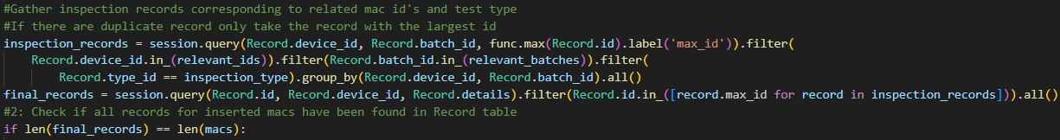
Figure 45: Code used to check if an inspection record has been opened for all input sensors.
If some or all sensors don’t have an opened inspection record relating to the test in question the following prompt will occur:
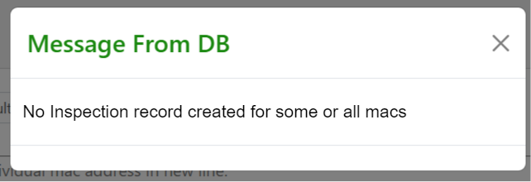
Figure 46: "No inspection record created for some or all macs" prompt.
The user will also be able to see a table containing a list of all the mac id’s missing from the inspection.record table as seen in Figure 7.
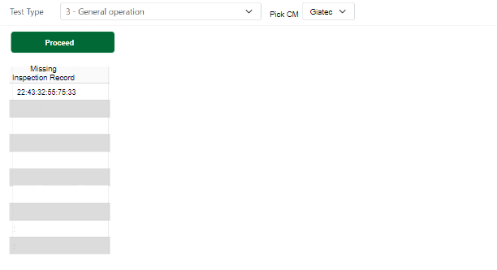
Figure 47: Table with list of macs missing inspection records.
Step 3: Check for pre-existing data in details column.
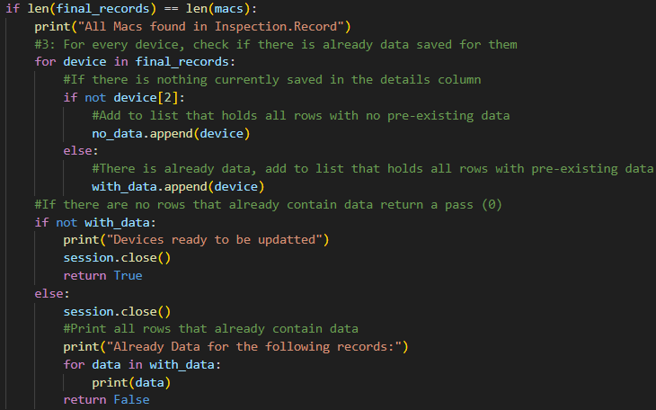
Figure 48: Code which checks if rows for inserted macs already contain data for related test type.
If some or all sensors already have inserted data for the test type in question, the user will be shown a prompt like Figure 9 along with a list of the macs for which data has already been inserted. The user will then be able to decide whether they want to overwrite the current data for the listed sensors.
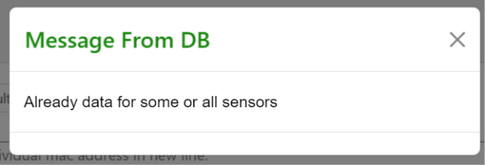
Figure 49: Already data prompt.
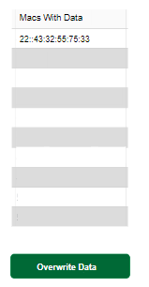
Figure 50: List of sensors with data and button to overwrite.
If all three checks pass or if the user chooses to overwrite the data after the third check fails, the following prompt will come up:
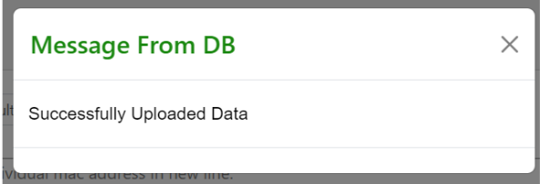
Figure 51: Data successfully entered prompt.

